INTRAGENOTYPIC DIVERSITY OF PORCINE ROTAVIRUS STRAINS CIRCULATING IN SÃO PAULO STATE, BRAZIL

(DIVERSIDADE INTRA-GENOTÍPICA DE AMOSTRAS DE ROTAVÍRUS SUÍNAS CIRCULANTES NO ESTADO DE SÃO PAULO, BRASIL.)

F. GREGORI^{1*}, P. E. BRANDÃO¹ AND J. A. JEREZ¹

SUMMARY

In order to determine the intragenotypic diversity of rotaviruses circulating in swine farms located in different cities in São Paulo, Brazil, a total of three G[5] rotavirus samples were subjected to partial sequencing of the VP7-encoding gene. Similarly, another four P[6] samples had their VP4-encoding gene partially defined. The nucleotide identity amongst G[5] samples ranged from 93.1% to 99.4%, and in terms of amino acids, 97.5% to 100%. With regard to the genotype P[6], 93% to 98.7% and 95 to 100% for nucleotide and amino acids identities, respectively. Besides, the amino acid-based phylogeny using Neighbor-Joining distance algorithm and Poisson correction as substitution model, demonstrated that samples G[5] defined herein grouped exclusively with homologous strains previously described in pigs while the P[6] demonstrated a relationship both with human and porcine rotavirus. In face of these findings, one may conclude that there is heterogeneity of porcine rotavirus strains circulating in pig herds in the State of São Paulo belonging to the same genotype.

KEY-WORDS: Swine, rotavirus, genotypes.

RESUMO

Com o objetivo de se determinar a diversidade intra-genotípica de rotavírus circulantes em criações de suínos de diferentes cidades localizadas no Estado de São Paulo, Brasil, um total de 3 amostras de rotavírus pertencentes ao genotipo G[5] foram submetidas ao sequenciamento parcial do gene codificador da proteína VP7. Analogamente, outras 4 amostras P[6], tiveram o gene codificador da proteína VP4 parcialmente definidas. A identidade nucleotídica entre as amostras G[5] variou de 93,1% a 99,4%, e em termos de aminoácidos de 97,5% a 100%. Quanto ao genotipo P[6], de 93% a 98,7% e 95 a 100% para as identidades de nucleotídeos e aminoácidos, respectivamente. Adicionalmente, inferências filogenéticas feitas a partir de aminoácidos, usando o critério de distância com algoritmo Neighbor-Joining e correção de Poisson como modelo de substituição, demonstraram que as amostras G[5] aqui definidas agruparam-se exclusivamente com amostras homólogas descritas previamente em suínos, enquanto que as P[6] demonstraram relacionamento tanto com amostras humanas e suínas. Em face destes achados, pode-se concluir que há uma heterogeneidade de amostras suínas de rotavírus circulantes nos rebanhos suínos do Estado de São Paulo pertencentes a um mesmo genotipo.

PALAVRAS-CHAVE: Suínos, rotavírus, genotipos.

INTRODUCTION

The porcine rotaviruses are one of the main causes of diarrhea in livestock, occurring enzootically and affecting mostly young animals (WIELER et al., 2001; KATSUDA et al., 2006).
This virus belongs to the Reoviridae family, genus Rotavirus, and it is characterized by a genome consisting of 11 fragments of double-stranded RNA, surrounded by a triple layer protein, in which the core is formed by proteins VP1, VP2 and VP3, the intermediate by VP6 which also serves as basis for classification into groups (A to G), and two outer, VP4 and VP7, whose respective encoding genes are (group A) markers for P and G genotypes (RAMIG et al., 2005; ESTES & KAPIKIAN, 2007).
In pigs, it has been described more frequently group A rotaviruses belonging to genotype G[3], G[4], G[5] associated with P[6] or P[7] (CHAN-IT et al., 2008; GREGORI et al., 2009). These viruses have some characteristics that increase their genetic variability, including a great number of excreted particles during the infection, wide range of susceptible species, resistance to environmental conditions, and the possibility of concurrent infections of different serotypes in the same individual (GOUVEA & BRANTLY 1995; JAIN et al., 2001; KOOPMANS & DUIZER, 2004; ESTES & KAPIKIAN, 2007; COLLINS et al., 2010). Moreover, the mechanisms by which rotavirus strains emerge involve point mutations (drifts), generation of reassortants, rearrangements (TANIGUCHI & URASAWA, 1995) and intragenic recombination (PARRA et al., 2004).
Genetic differences within the same genotype have already been demonstrated (MATTHIJNSSENS et al., 2008) including VP4 and VP7 genes (ARISTA et al., 2005; COLLINS et al., 2010; LAMHOUJEB et al., 2010), that may bring implications in terms of zoonotic transmission (MARTELLA et al., 2010), selection of vaccine strains, and the improvement of diagnostic methods (ARISTA et al., 2005; KERIN et al., 2007).
The aim of this study was to determine the intragenotypic diversity of circulating rotaviruses on swine farms located in different cities in São Paulo State, Brazil, based on partial sequencing of the VP4- and VP7-encoding genes given the restricted data availability about Brazilian samples.

MATERIAL AND METHODS

A total of 7 diarrheic fecal samples were collected between the years 1999 to 2001 from different commercial farms located in six cities of São Paulo State, Brazil, previously screened as positive for rotavirus by Polyacrylamide Gel Electrophoresis (PAGE) (HERRING et al., 1982) and polyclonal double-sandwich Elisa (GREGORI et al., 2000).
From a 50% (v/v) fecal suspension in TRIS-HCl 0.1 M pH 7.3, centrifugated at 12,000 g for 30 minutes, total RNA was extracted with TRIzol Reagent™ (Invitrogen, Carlsbad, CA, USA) as described by the manufacturer.
The G and P genotyping were carried out with nested multiplex RT-PCR (GOUVEA et al., 1994a,b). To avoid DNA carryover contamination, each reaction step was performed in separate rooms. The NCDV rotavirus strain was used as positive control and ultrapure water as negative.
The products obtained from RT-PCR reactions were purified directly from agarose gels, using the Concert Kit (Invitrogen, Carlsbad, CA, USA), and submitted to a bi-directional DNA sequencing with BigDye 3.1 (Applied Biosystems, Carlsbad, CA, USA), according to the manufacturer's instructions without prior cloning. Sequences were resolved in an ABI-310 (Applied Biosystems, Carlsbad, CA, USA) and submitted in GenBank (Table 1).
The respective G[5] and P[6] nucleotide sequences were aligned each other and with other homologous counterparts retrieved from GenBank, using Clustal W 1.83 software (THOMPSON et al., 1994), using (accession number/sample name/host): a) Genotype G[5]: X04613/OSU/pig; DQ813658/344-04-1/pig; DQ062572/134-04-15/pig; DQ515961/CMP178/pig; L35054/A46/pig; L35059/A34/pig; L35058/C134/pig; L35056/CC117/pig; AY538665/JL94/pig; DQ857956/RJ40644-90/Human; DQ857955/RJ35400-87/Human; EF672588/IAL28/Human; b) Genotype P[6]: AY955309/221-04-21/pig; AY955302/221-04-13/pig; AY955301/134-04-8/pig; AY955300/134-04-11/pig; AB176685/JP3-6/pig; AY955304/51-02/pig; M33516/GOTTFRIED/pig; L20877/M37/Human.
Swine Group C rotavirus with accession numbers M61101 and M74218, were additionally included as outgroup respectively for the phylogenetic analysis of genotype G[5] and P[6].
The values ​​of the similarities between nucleotide and amino acid sequences were obtained using BioEdit v. 7.0.5.3 (HALL, 1999) software. The amino-acid based phylogenetic inference was performed using the distance criterion, with Neighbor-Joining method and substitution model Poisson Correction, with 1,000 bootstrap replicates, using MEGA 4 (TAMURA et al., 2007).

RESULTS

Out of the seven samples tested it was only possible to define the genotype P[6] in four of them and as for the genotype G[5], only 3 samples were characterized. This data is presented on Table 1 according to its identification code, accession number, genotype and geographical origin.
The range of identity values ​​of nucleotide and amino acid sequences from samples presented herein and compared with other homologous selected from GenBank, are shown in Table 2.
The alignment of amino acid sequences corresponding to residues 92-212 (according to OSU sample X04613) of the VP7-encoding gene is shown in Figure 1.
The amino acid-based phylogenetic tree of the partial fragment of rotavirus VP7-encoding gene is presented in Figure 2, depicting a cluster among the strains defined herein (indicated with arrows) and other porcine rotavirus (A46, A34, OSU, and JL94). Numbers at each node are the bootstrap values obtained with 1,000 replicates and the scale represents the number of substitutions per site.
The alignment of amino acid sequences corresponding to residues 184-264 (according to Gottfried sample M33516) of the VP4-encoding gene, is shown in Figure 3.
The amino acid-based phylogenetic tree of the partial fragment of rotavírus VP4-encoding gene is presented in Fig.4, on which the Brazilian porcine rotavirus strains JJ6, JJ7, and JJ8 (indicated with arrows) have been segregated in a clade while the JJ4 grouped together with the homologous strain 51/02.

DISCUSSION

Both VP7 and VP4 (with regard to its cleavage sub-products VP8* and VP5*) proteins interact with the membrane of host cells (CARTER & SAUNDERS, 2007) and are independently involved with the induction of neutralizing antibodies (ESTES & KAPIKIAN, 2007). In doing so, they are a parameter for selection of vaccine samples (KIRKWOOD, 2010) and the intragenotypic variation may be one possible explanation not only for the failure of vaccine protection but to provide a better fitness for interspecies transmission.
Indeed, with regard to VP7, the region sequenced corresponds to residues 92 to 212, including part of regions A and C as well as the whole of B, responsible for the neutralization epitopes (MATTION et al., 1994).
The G[5] strains defined herein had their nucleotide similarity ranged from 93.1% to 99.4% while in terms of amino acids between 97.5% to 100% (Table 2). The substitutions were detected D54N, G55E and T80A, as shown in Fig.1. With regard to the geographical origin samples, there was complete identity between those from the cities of Itú and Itaberá (JJ10 and JJ12), even though they are far apart approximately 260 km, while within the same municipality (Itú) it was detect heterogeneity of circulating strains (JJ12 and JJ13), but small (2.5%) and may represent distinct viral introductions. It is noteworthy that the cysteine ​​residues in the region aligned (Fig.1, positions 44, 74, 100, 105, 116), which are responsible for maintaining protein conformation by disulfide bonds (ESTES & COHEN, 1989), were conserved among all the samples of the panel.
There was a high identity among the Brazilian porcine samples with the OSU (X04613) strain, limited to the substitutions D66G, T80M (or A80M), and A46 (L35054), with a 100% identity for samples JJ10 and JJ12, but on the other hand, the lower limit of nucleotide identity (83.7%) occurred between the samples and CMP178 and JJ13.
Considering the sequenced region, it is not possible to conclude that the Brazilian rotavirus porcine samples constitute a sub-lineage, although previous studies have already demonstrated divergence of the genes encoding VP7 from other genotypes by comparing, for example, those belonging to G4 in humans and pigs (ARISTA et al., 2005; COLLINS et al., 2010). With regard to the G5, Silva et al. (2011) defined three different lineages, in which two of them co-exist both human and porcine strains. In fact, according to Fig.1, human rotaviruses G[5] previously described in Brazil, presented a higher polymorphism when compared to the swine, notably the substitutions D5T, D9T, and I55G/E/V/A.
These findings were in agreement with the G[5] tree topology (Fig.2) in which the Brazilian samples JJ10 and JJ12 clustered together with the strain A46, due to the absence of polymorphisms in the sequenced fragment, resulting in a polytomy. On the other hand, the sequencing data demonstrated strain relatedness between strains JJ13, JL94, and OSU, while the tree topology denotes a greater distance between the porcine samples and those isolated from humans, which in its turn formed a separate group (Fig.2).
Considering the P[6] genotype, the sequenced VP4-encoding gene region (residues 184-264) comprises mainly the VP8* cleavage product (MATTION et al., 1994). The amino acid identity values ​​ranged from 95% to 100% (Table 1), with maximum value presented between samples from the cities of Piedade (JJ6) and Bragança Paulista (JJ8), geographically apart around 170 km. These taxa also differed by only a single amino acid substitution (H61Y) from the strain JJ7 (Fig.3), also reflected by tree topology (Fig.4). The JJ4 strain kept a greater phylogenetic relationship with the porcine 51/02 sample, previously described in Spain. The amino acid substitutions found among the samples sequenced in this study are V13I, V49I, Y61H, and R62Q.
Martella et al. (2006) through analysis of VP8*, observed that porcine rotavirus can be characterized into different strains within the same genotype P[6], but observed higher degree of nucleotide and amino acid similarity with the human prototype sample M37 (strain I) than with Gottfried porcine strain (lineage II), suggesting a strong relationship between the evolution of animal and human rotavirus. The tree topology shown in Fig.4, is in agreement with this fact, since the porcine samples JJ4, JJ6, JJ7, and JJ8 presented close relationship with the M37, although the hypervariable region B, located between residues 92 at 192, was not included in this analysis.
It is expected that the VP4- and VP7-encoding genes have different levels of nucleotide conservation since they are targets of host neutralizing antibodies (TANIGUSHI & URASAWA, 1995), in doing so the comparison of the pathogenicity and virulence caused by amino acid substitutions is necessary for a more comprehensive understanding of rotavirus infection as well as for the prediction of the efﬁciency of immunogens. Moreover, it was not possible to characterize simultaneously the G and P genotypes from the samples studied, which may be attributed to the variability in primer binding sites (KERIN et al., 2007; COLLINS et al., 2010) making necessary to constantly review or update these oligonucleotides as more sequencing data become available.
Despite of partial regions of the VP4- and VP7-encoding genes have been taken into consideration and the relatively small sample size, it is possible to conclude that there is a mix of porcine rotavirus belonging to the same genotype circulating in swine herds in São Paulo State, Brazil.

ACKNOWLEDGEMENTS
To Mr. Alexandre Abelardo Sanches for technical assistance and FAPESP (Fundação de Amparo à Pesquisa do Estado de São Paulo) for financial support (Proc.99/05912-9).

REFERENCES

ARISTA, S.; GIAMMANCO, G. M.; DE GRAZIA, S.; COLOMBA, C.; MARTELLA, V. Genetic variability among serotype G4 Italian human rotaviruses. Journal of Clinical Microbiology, v.43, p.1420-1425, 2005.

CARTER, J. B.; SAUNDERS, V. A. Virology: Principles and applications. West Sussex: John Wiley and Sons Ltd, 2007, p.147-156.

CHAN-IT, W.; KHAMRIN, P.; SAEKHOW, P.; PANTIP, C.; THONGPRACHUM, A.; PEERAKOME, S.; USHIJIMA, H.; MANEEKARN, N. Multiple combinations of P[13]-like genotype with G3, G4, and G5 in porcine rotaviruses. Journal of Clinical Microbiology, v.46, p.1169-1173, 2008.

COLLINS, P. J.; MARTELLA, V.; SLEATOR, R. D.; FANNING, S.; O'SHEA, H. Detection and characterization of group A rotavirus in asymptomatic piglets in Southern Ireland. Archives of Virology, v.155, p.1247-1259, 2010.

ESTES, M. K.; KAPIKIAN, A. Z. Rotaviruses. In: KNIPE D. M.; HOWLEY P.M. (Eds.). Fields Virology. Philadelphia: Lippincott Williams and Wilkins, 2007, p.1918-1976.

GOUVEA, V.; BRANTLY, M. Is rotavirus a population of reassortants? Trends in Microbiology, v.3, p.159-162, 1995.

GOUVEA, V.; SANTOS, N.; TIMENETSKY, M. C. Identification of bovine and porcine rotavirus G types by PCR. Journal of Clinical Microbiology, v.32, p.1338-1340, 1994a.

GOUVEA, V.; SANTOS, N.; TIMENETSKY, M. C. VP4 typing of bovine and porcine group A rotaviruses by PCR. Journal of Clinical Microbiology, v.32, p.1333-1337, 1994b.

GREGORI, F.; BRANDÃO, P. E.; ROSALES, C. A. R.; CORTEZ, A.; HEINEMANN, M. B.; RICHTZENHAIN, L.; JEREZ, J. A. Desenvolvimento de um método de ELISA para a detecção de rotavírus a partir de material fecal. Arquivos do Instituto Biológico, v.67, p.191-194, 2000.

GREGORI, F.; ROSALES, C. A. R.; BRANDÃO, P. E.; SOARES, R. M.; JEREZ J. A. Diversidade genotípica de rotavírus suínos no Estado de São Paulo. Pesquisa Veterinária Brasileira, v.29, p.707-712, 2009.

HALL, T. A. Bioedit: A user-friendly biological sequence alignment editor and analysis program for windows 95/98/nt. Nucleic Acids Symposium Series, p.41, p.95-98, 1999.

HERRING, A. J.; INGLIS, N. F.; OJEH, C. K.; SNODGRASS, D. R.; MENZIES, J. D. Rapid diagnosis of rotavirus infection by direct detection of viral nucleic acid in silver-stained polyacrylamide gels. Journal of Clinical Microbiology, v.16, p.473-477, 1982.

JAIN, V.; DAS, B. K.; BHAN, M. K.; GLASS, R. I.; GENTSCH, J. R.; INDIAN STRAIN SURVEILLANCE COLLABORATING LABORATORIES. Great diversity of group A rotavirus strains and high prevalence of mixed rotavirus infections in India. Journal of Clinical Microbiology, v.39, p.3524-3529, 2001.

KATSUDA, K.; KOHMOTO, M.; KAWASHIMA, K.; TSUNEMITSU, H. Frequency of enteropathogen detection in suckling and weaned pigs with diarrhea in Japan. Journal of Veterinary Diagnostic Investigation, v.18, p.350-354, 2006.

KERIN, T. K.; KANE, E. M.; GLASS, R. I.; GENTSCH, J. R. Characterization of VP6 genes from rotavirus strains collected in the United States from 1996-2002. Virus Genes, v.35, p.489-495, 2007.

KIRKWOOD, C. D. Genetic and antigenic diversity of human rotaviruses: Potential impact on vaccination programs. The Journal of Infectious Diseases, v.202, p.S43-S48, 2010.

KOOPMANS, M.; DUIZER, E. Foodborne viruses: an emerging problem. International Journal of Food Microbiology, v.90, p.23-41, 2004.

LAMHOUJEB, S.; COOK, A.; POLLARI, F.; BIDAWID, S.; FARBER, J.; MATTISON, K. Rotaviruses from Canadian farm samples. Archives of Virology, v.155, p.1127-1137, 2010.

MARTELLA, V.; BÁNYAI, K.; CIARLET, M.; ITURRIZA-GÓMARA, M.; LORUSSO, E.; DE GRAZIA, S.; ARISTA, S.; DECARO, N.; ELIA, G.; CAVALLI, A.; CORRENTE, M.; LAVAZZA, A.; BASELGA, R.; BUONAVOGLIA, C. Relationships among porcine and human P[6] rotaviruses: evidence that the different human P[6] lineages have originated from multiple interspecies transmission events. Virology, v.344, p.509-519, 2006.

MARTELLA, V.; BÁNYAI, K.; MATTHIJNSSENS, J.; BUONAVOGLIA, C.; CIARLET, M. Zoonotic aspects of rotaviruses. Veterinary Microbiology, v.140, p.246-255, 2010.

MATTHIJNSSENS, J.; CIARLET, M.; HEIMAN, E.; ARIJS, I.; DELBEKE, T.; MCDONALD, S. M.; PALOMBO, E. A.; ITURRIZA-GÓMARA, M.; MAES, P.; PATTON, J. T.; RAHMAN, M.;VAN RANST, M. Full genome-based classification of rotaviruses reveals a common origin between human Wa-Like and porcine rotavirus strains and human DS-1-like and bovine rotavirus strains. Journal Virology, v.82, p.3204-3219, 2008.

MATTION, N. M.; COHEN, J.; ESTES, M. K. The rotavirus proteins. In: KAPIKIAN, A. Z. (Ed.). Viral Infections of the Gastrointestinal Tract. 2 ed. New York: Marcel-Dekker Inc., 1994, p.169-249.

PARRA, G.I.; BOK. K.; MARTÍNEZ. M.; GOMEZ, J.A. Evidence of rotavirus intragenic recombination between two sublineages of the same genotype. Journal of General Virology, v.85, p.1713-1716, 2004.

RAMIG, F.; CIARLET, M.; MERTENS, P. P. C.; DERMODY, T. S. Rotavirus. In: FAUQUET, C. M.; MAYO, M. A.; MANILOFF, J.; DESSELBERGER, U.; BALL, L.A. Virus taxonomy: eighth report of the International Committee on Taxonomy of Viruses. Amsterdam: Elsevier, 2005, p. 484-496.

SILVA, M. F.; TORT, L. F.; GOMÉZ, M. M.; ASSIS, R. M.; VOLOTÃO, E. M.; MENDONÇA, M. C.; BELLO, G.; LEITE, J. P. VP7 gene of human rotavirus A genotype G5: phylogenetic analysis reveals the existence of three different lineages worldwide. Journal of Medical Virology, v.83, p.357-366, 2011.

TAMURA K.; DUDLEY J.; NEI, M.; KUMAR, S. MEGA4: Molecular Evolutionary Genetics Analysis (MEGA) software version 4.0. Molecular Biology and Evolution, v.24, p.1596-1599, 2007.

TANIGUCHI, K.; URASAWA, S. Diversity in rotavirus genomes. Seminars in Virology, v.6, p.123-131, 1995.

THOMPSON, J. D.; HIGGINS, D. G.; GIBSON T. J. CLUSTAL W: Improving the sensitivity of progressive multiple sequence alignment through sequence weighting, position-specific gap penalties and weight matrix choice. Nucleic Acids Research, v.22, p.4673-4680, 1994.

WIELER, L. H.; ILIEFF, A.; HERBST, W.; BAUER, C.; VIELER, E.; BAUERFEIND, R.; FAILING, K.; KLÖS, H.; WENGERT, D.; BALJER, G.; ZAHNER, H. Prevalence of enteropathogens in suckling and weaned piglets with diarrhoea in southern Germany. Journal of Veterinary Medicine (Series B), v.48:151-159, 2001.

Table 1. List of sequenced rotavirus samples, according to its identification code, accession number, genotype and geographical origin

Identification | Accession number | Genotype | City / State
JJ4 | DQ473526 | G[-]ª P[6] | Itaberá / SP
JJ6 | DQ473528 | G[-] P[6] | Piedade / SP
JJ7 | DQ473529 | G[-] P[6] | Capivari / SP
JJ8 | DQ473530 | G[-] P[6] | Bragança Paulista / SP
JJ10 | DQ473532 | G[5] P[-] | Ibiúna / SP
JJ12 | DQ473534 | G[5] P[-] | Itú / SP
JJ13 | DQ473535 | G[5] P[-] | Itú / SP
ª [-] = undefined genotype.

Table 2. Range of nucleotide and amino acid identities of rotavirus VP7 (genotype G[5]) and VP4 (genotype P[6]) partial sequences

Genotype | Identity | Nucleotide (min-max) | Amino acid (min-max)
G[5] | Among the sequences generated in this study | 93.1% - 99.4% | 97.5% - 100%
G[5] | Among the sequences generated in this study compared to Genbank counterparts | 83.7% - 95% | 91.7% - 100%
P[6] | Among the sequences generated in this study | 93% - 98.7% | 95% - 100%
P[6] | Among the sequences generated in this study compared to Genbank counterparts | 83.5% - 93.4% | 86.4% - 98.7%

FIGURE LEGENDS

Fig.1. Alignment of a 121-long amino acid fragment of the rotavirus VP7-encoding gene, corresponding to residues 92-212 (according to OSU sample X04613). Samples JJ10, JJ12 e JJ13 were generated in this study.

Fig.2. Neighbor-Joining phylogenetic tree for a stretch of 221 nucleotides of the gene encoding for the VP7 of rotavirus, with Group C rotavirus (Accession number M6101) as outgroup. Taxa with an arrow are related to Brazilian field strains from the present study; numbers at each node are the bootstrap values obtained with 1,000 replicates and the scale represents the number of substitutions per site.

Fig.3. Alignment of a 81-long amino acid fragment of the rotavirus VP4-encoding gene, corresponding to residues 184-264 (according to Gottfried strain accession number M33516). Samples JJ4, JJ6 e JJ7, and JJ8 were generated in this study.

Fig.4. Neighbor-Joining phylogenetic tree for a stretch of 81 nucleotides of the gene encoding for the VP4 of rotavirus, with Group C rotavirus (Accession number M74218) as outgroup. Taxa with an arrow are related to Brazilian field strains from the present study; numbers at each node are the bootstrap values obtained with 1,000 replicates and the scale represents the number of substitutions per site.

FIGURES

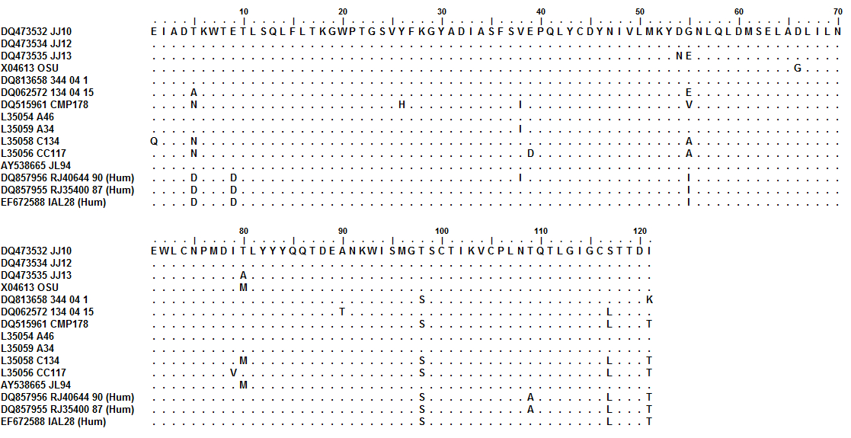
Figure 1

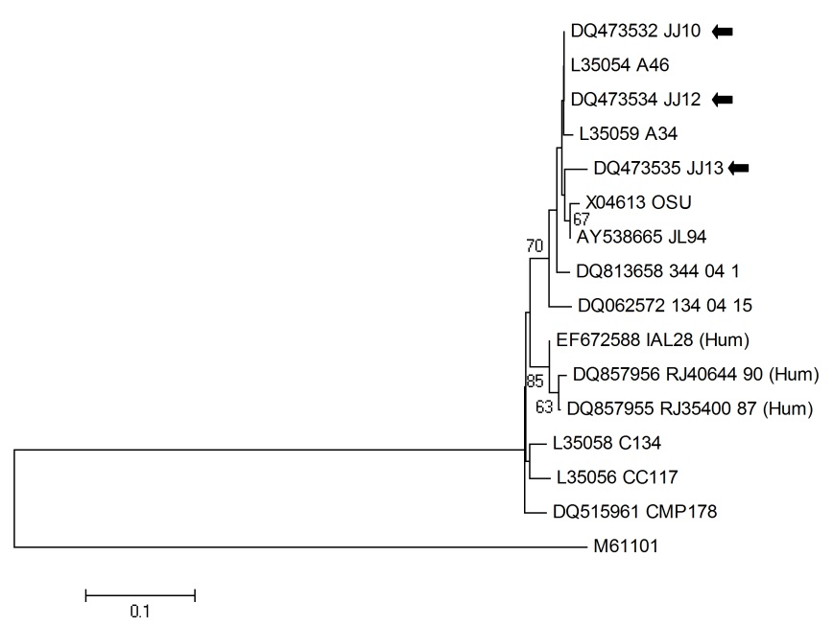
Figure 2

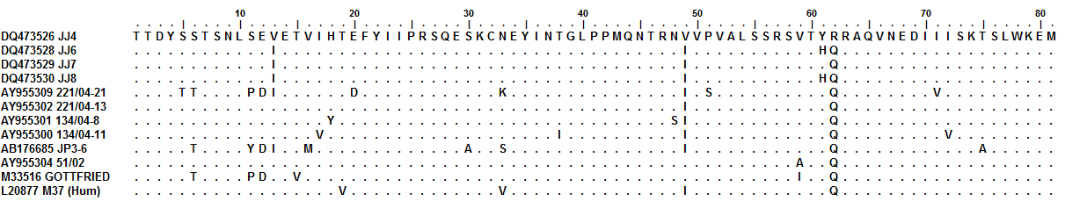

Figure 3

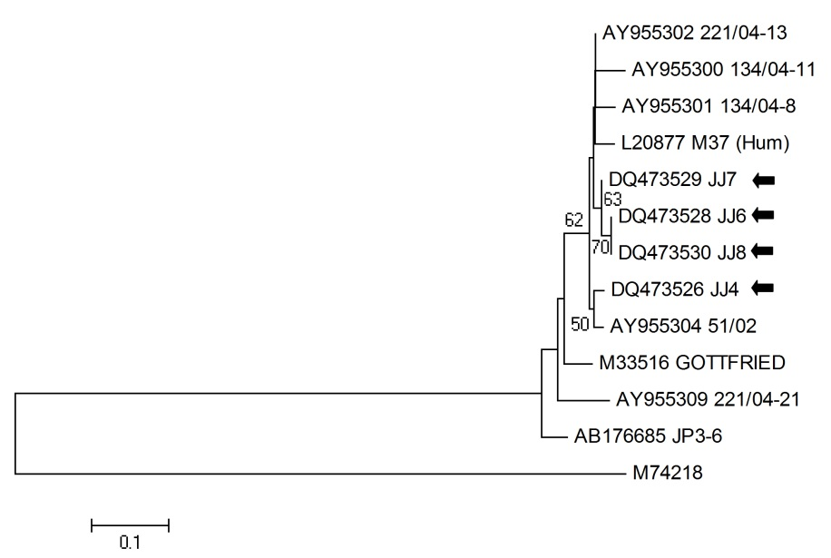

Figure 4

Departamento de Medicina Veterinária Preventiva e Saúde Animal. Faculdade de Medicina Veterinária e Zootecnia. Universidade de São Paulo (USP). Av. Prof. Dr. Orlando Marques de Paiva 87, São Paulo – SP, Brazil. CEP 05508-270. *Corresponding author: fabiogregori@gmail.com

