Mariana Froner Casagrande
São Paulo State University – Campus of Jaboticabal
Rod. Prof. Paulo Donatto Castelani s/n, Jaboticabal, SP, Brazil, Veterinary Pathology Department.
55 16 3209 7100 ramal: 7838
Correspond e-mail: marianafcasagrande@yahoo.com.br

AUTHOR AGREEMENT

Dear Editor,

The authors agree with the manuscript entitled " Quantificação de Enterobactérias e Clostridium spp. em esteiras condutoras de cortes de frango em frigoríficos." submitted for consideration in Ars Veterinária.

Author's names and email address:

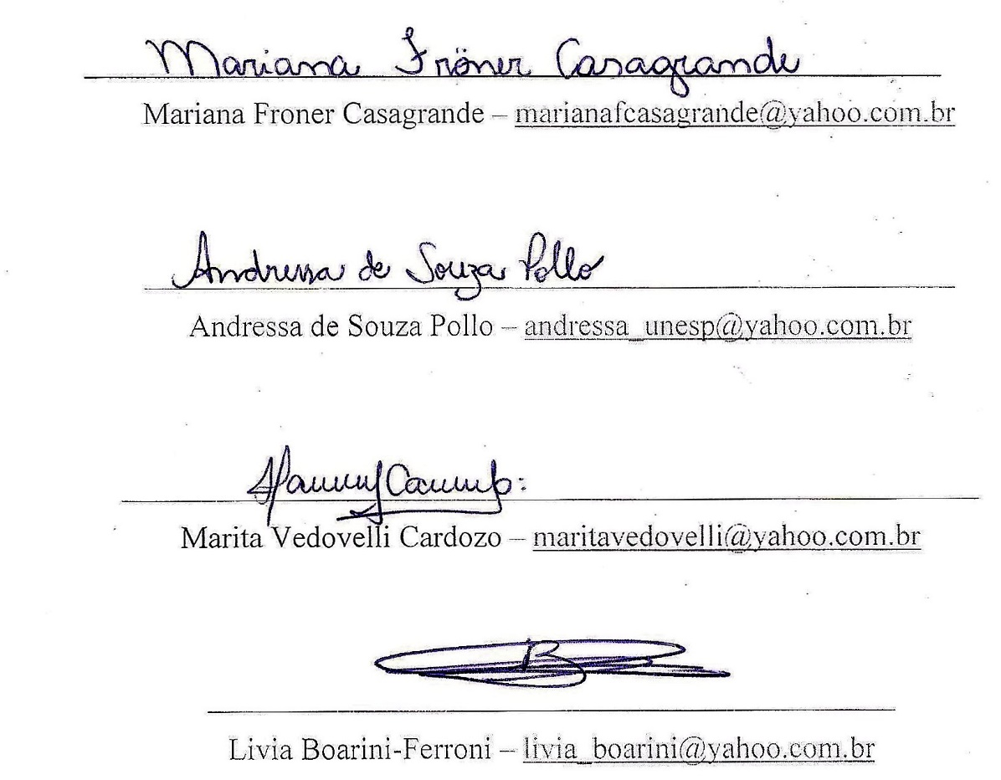
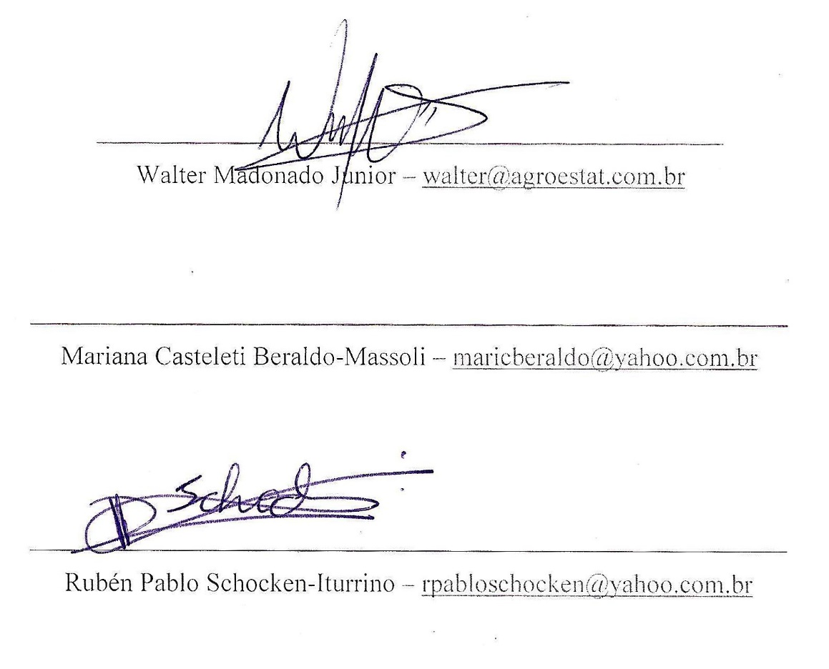

Jaboticabal, January 16th, 2018.

